Application Profiling – Data

|  |  |  |  |  |
| --- | --- | --- | --- | --- |
| Identifier | Malloc cycles | Free cycles | Outside cycles | Average frag |
| FL-Re | 476296 | 1506849 | 8972302 | 40.26% |
| BMP-Re | 61671154 | 1590591 | 8971744 | 70.764% |
| B-Re | 21112853 | 598198 | 8971868 | 82.086% |

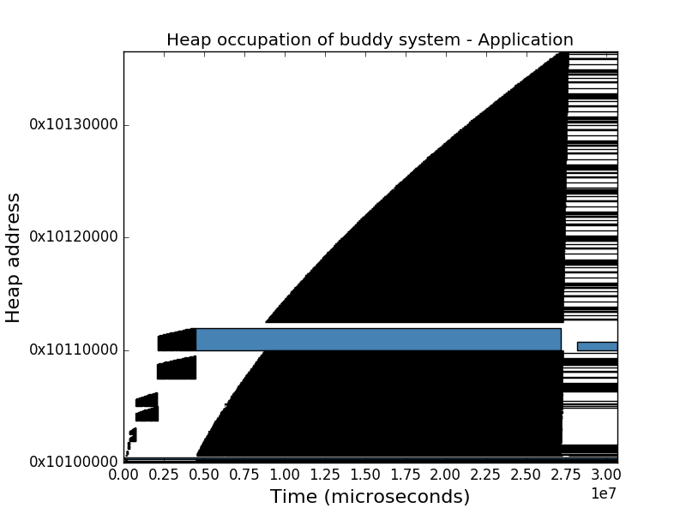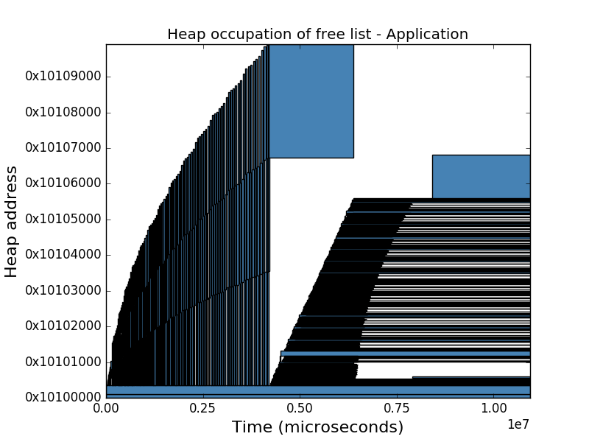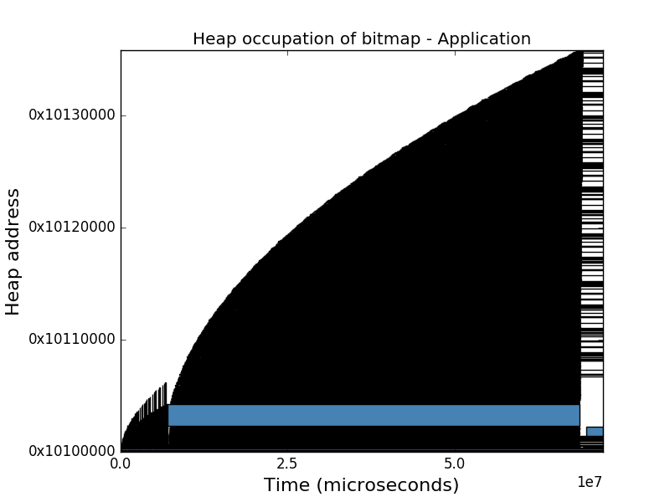Parameters  
HeapSize:384 KB  
Bitmap minimum grainsize 256  
Buddy system minimum grain size 256